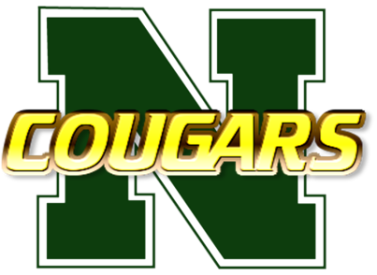
Classroom/Lab Expectations
Mr. Stephen Swann

- Safety First!
All science lab safety protocols must be followed at all times. Students are required to endorse and comply with a lab safety contract in order to participate in lab classes and activities. A violation of any safety regulation will result in immediate dismissal from the lab and a grade of zero (“0”) issued for that activity.
- Respect!
Respect yourself to maintain proper behavior and work ethic. Respect your classmates and their efforts. Respect your school by taking care of lab property and equipment.
- Responsibility!
You are responsible for the quality of your actions, your work, and your behavior.
- Hard Work!
All work will be complete, prompt, and kept in a designated workbook/binder. Work should be of the highest quality and demonstrate student knowledge and skills. Show off for me!
- Makeup Work!
You must make up any missed work. You are responsible for finding out what you missed. You have 3 days to make up work from an excused absence. There is a 10-point penalty for each day an assignment is late.

